

**The University of Azad Jammu and Kashmir,**

**Muzaffarabad**

|  |  |
| --- | --- |
| Name | Kamal Ali Akmal |
| Course Name | Computer Architecture and Logic Design |
| Submitted to | Engr. Sidra Rafique |
| Semester | 2nd |
| Session | 2024-2028 |
| Roll No | 2024-SE-38 |
| Lab No | 08 |
| Submission date | 28 August 2025 |

**Addition**

**Solution:**

**Decimal form**

1. mov ax,2342d

mov bx, 6534d

add ax, bx

Solution

**manually,**

We have ax=2342d and bx =6534d

First, we have to change the given decimal into binary form binary form,

ax=0000100100100110

bx=0001100110000110

adding both we get, also I used 2's compliment here,

ax=10001010101100

now change it into hexadecimal

we get ax=22AC

**By using emulator,**

**Step #01:**

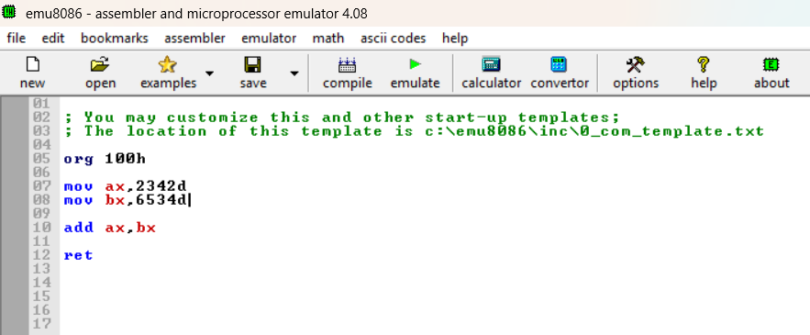

**Source code:**

**Binary window:**

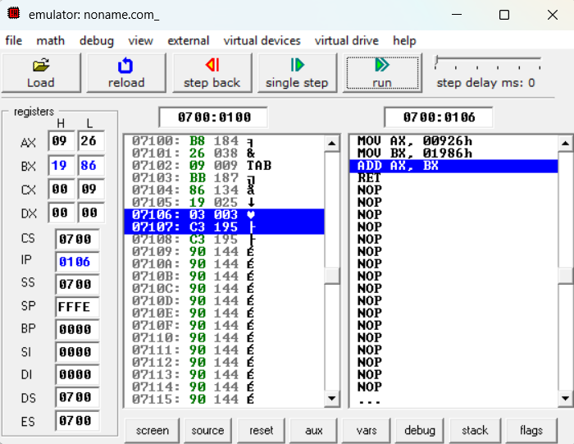

**Step #02:**

Ax=



**Step #03:**

Bx=



**Step #04:**

**Result:**



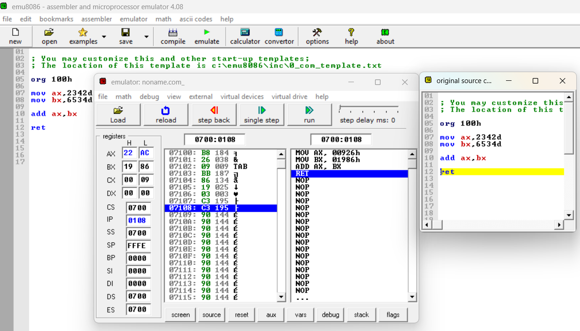

**Subtraction**

**Solution:**

**Decimal form**

1. mov ax,374d

mov bx, 64d

add ax, bx

Solution

**manually,**

We have ax=374d and bx =64d

First, we have to change the given decimal into binary form binary form,

ax= 0000000101110110

bx= 0000000001000000

adding both we get, also I used 2's compliment here,

ax=1111111010001001

now change it into hexadecimal

we get ax=FE89

**By using emulator,**

**Step #01:**

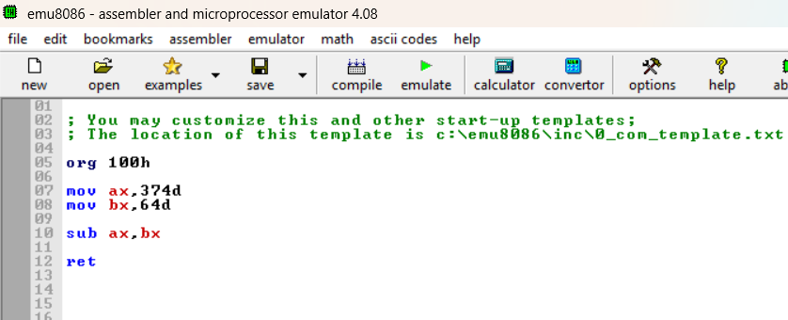

**Source code:**

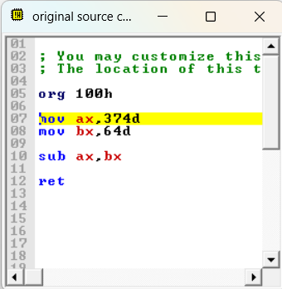

**Binary window:**

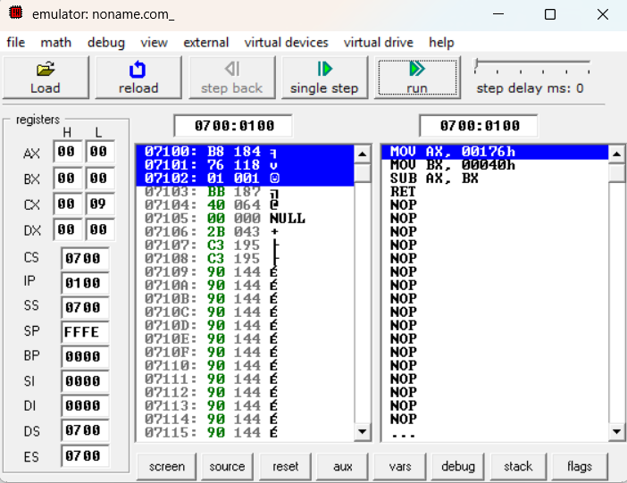

**Step #02:**

Ax=



**Step #03:**

Bx=



**Step #04:**

**Result:**



**Multiplication**

**Solution:**

**Decimal form**

1. mov ax,34d

mov bx, 47d

add ax, bx

Solution

**manually,**

We have ax=34d and bx =47d

First, we have to change the given decimal into binary form binary form,

ax=00100010

bx=00101111

adding both we get, also I used 2's compliment here,

ax=11011101

now change it into hexadecimal

we get ax=DD

**By using emulator,**

**Step #01:**

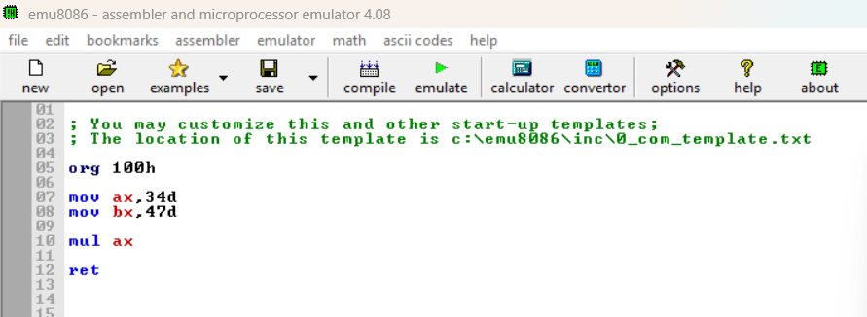

**Source code:**

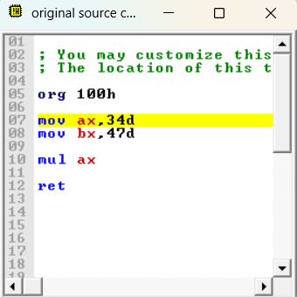

**Binary window:**

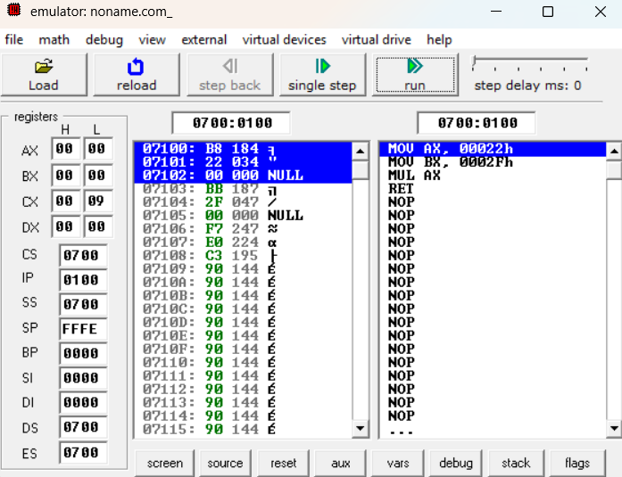

**Step #02:**

Ax=



**Step #03:**

Bx=



**Step #04:**

**Result:**



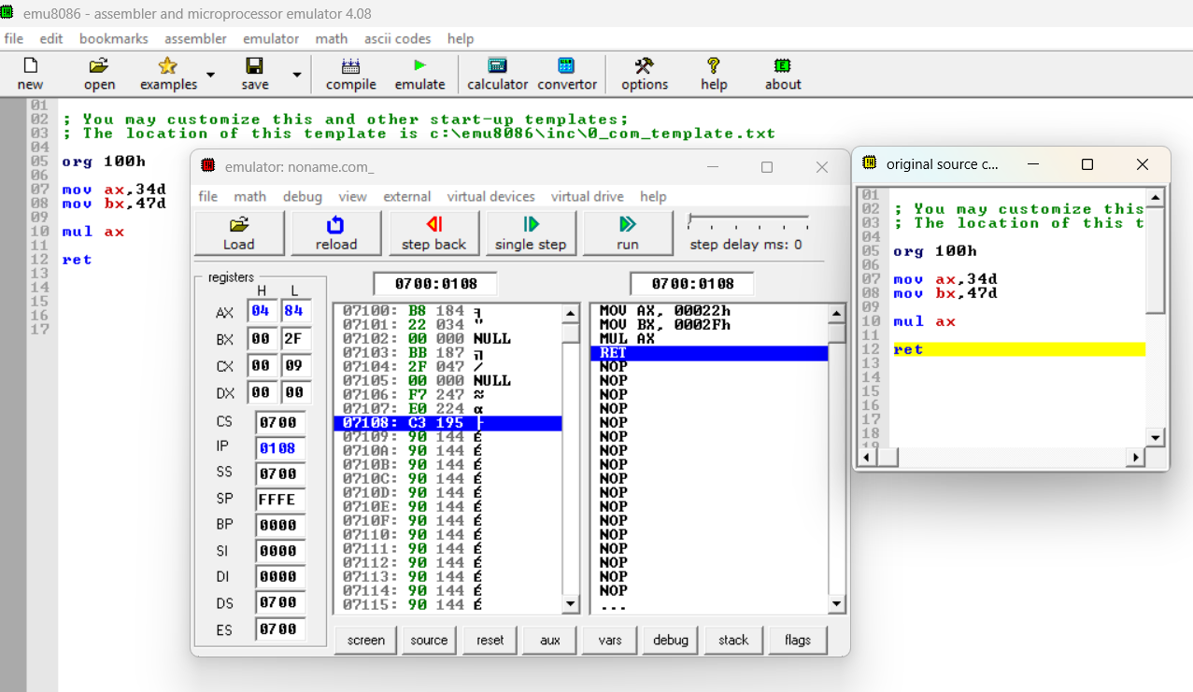

**Division**

**Solution:**

**Decimal form**

1. mov ax,5000d

mov bx, 50d

add ax, bx

Solution

**manually,**

We have ax=5000d and bx =50d

First, we have to change the given decimal into binary form binary form,

ax=1100001101010000

bx=0000000000110010

adding both we get, also I used 2's compliment here,

ax=0011110010101111

now change it into hexadecimal

we get ax=3CAF

**By using emulator,**

**Step #01:**

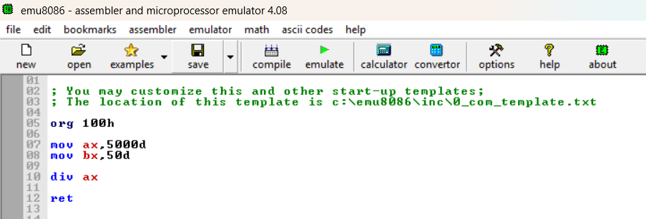

**Source code:**

**Binary window:**

**Step #02:**

Ax=

**Step #03:**

Bx=



**Step #04:**

**Result:**



